Algorithmic Simulations of Hydrocortisone-Induced Degeneration

Abstract

The Elk River, Gulf Wars, and Atlantic Oxybenzone instances proved chemical contamination is a serious threat. HC is a common corticosteroid used to treat skin lesions that hasn't undergone testing. This research will utilize real plant cultivation, mathematical modeling, machine learning, and custom Python3 programming to determine the effect of HC on plant life. Metadata significant at a 0.01 level under 48 degrees of freedom was gathered by cultivating real *Raphanus sativus* plants treated with various levels of HC contaminated water; the t-test was verified using Java8 computer code. The simulation comprised of three independent algorithms. Because the metadata was very sparse, the first algorithm was dedicated to using modified bootstrapping to iteratively generate synthetic data points with less entropy. The second algorithm was a deep learning substructure incorporating concepts of linear regression and neural networks; the backpropagation used the MSE loss function and ADAM optimizer, which has aspects of previously engineered AdaGrad and RMSProp models. The third algorithm measured the effect of HC on a terrain based on aquatic content. The simulations used an HC contaminator based of the Gulf Wars event and five semi-aquatic terrains in North America, which were the contaminator and terrestrial parameters respectively. The plant cultivation and software simulations supported the research hypothesis stating that the uncontaminated plants would be healthiest was accepted. Future research could use convolutional neural networks to achieve a higher R-squared value and real-time procedural terrain generation to improve the simulations.

Introduction

Chemical pollution is an increasing threat to life and mankind. Drugs can be ecologically dangerous because they are engineered to alter biological states. Chemical disasters are most deadly when they are near water sources such as rivers, ponds, and lakes because water dissipates the pollution. Drug dissipation is correlated to aquatic and semi-aquatic environments because water is the universal solvent. There are many examples of chemical pollution destroying environments in the past. Some industrial spills were the 1991 Gulf Wars oil spill, 2014 Elk River contamination, and the 2019 Lake Michigan contamination. Even Oxybenzone, a chemical common in sunscreens, was strongly correlated to coral bleaching in 2018 (Raffa et al, 2018). These events show that both industrial and common chemicals can be harmful, therefore Hydrocortisone (HC) should be tested more.

After the Oxybenzone events, the FDA has considered revamping the laws in sunscreens. They could also create a new framework for other skin products, which would be a multimillion-dollar effort because many HC distributors would have to avert their paths from plant-heavy areas. Like Oxybenzone, HC’s most common usage is in skin cream (Raffa et al, 2018). If HC showed to be correlated to a change in plant health, then stricter laws would be implemented. If not, then many laws in the new framework could be lifted. The purpose of this experiment is to investigate the effect of HC on plant growth using interdisciplinary methods of botany, data analytics, and computer science.

The independent variable, or IV, for this experiment, is the HC concentration in the water supply. HC is a mutagen, which means that it can be found in wound healing substances. As seen in the three-dimensional model of HC in figure one, the molecular formula is C21H30O5 (Safety Data Sheet acc. to OSHA HCS, 2021). However, HC-based creams have many other ingredients as well. The over-the-counter HC creams are the most distributed. The creams are used to treat skin lesions and usually contain 0.5% or 1% pure HC. It works by reducing inflammation caused by a variety of diseases. Based on the background research done on HC, a research hypothesis was generated. The hypothesis stated that if a water supply with no HC contamination was used, then the plants hydrated with that water supply would be the healthiest.

To best investigate the botanic properties of HC, an ideal plant should be used for testing. During the procedure, *Raphanus sativus* plants will be used. *Raphanus sativus* plants are very common in plant-based procedures because they grow faster than other vascular plants. The germination and yield are very high and can also be localized in most environments. The dependent variables of this experiment were the height of the plants and the Brix score. Brix is a standardized measurement that returns the amount of sugar in the stem’s sap. The Brix measurement is useful when determining a plant’s overall health because higher sugar concentration is correlated to healthier plants. The data types are quantitative and are on a numerical x and y-axis. Also, the measurements are both on the ratio convention, which means the axes minimums are zero (Gutiérrez and Perez, 2004).

The levels of IV in this experiment are a 0.05% pure mutagen concentration and a 0.025% pure mutagen concentration. The concentrations are the relationship between pure HC and the amount of water given to the plants. Both these levels hold respect to a pure water supply, which is the positive control. In this experiment, low concentrations of pure HC mutagens are used because prescription HC medicine requires a lab. Restrictions from Covid-19 prevent a lab from being accessible. (Cova and Pais, 2019).

As an extension, this research will use an automatic computing simulator made of three concatenated algorithms. As can be seen in figure three, the first algorithm will modify traditional bootstrapping, which is completely randomized. The modification will add an extra parameter that allows manual control of the sensitivity, meaning that the range of the bootstrapping will remain a constant. This will be done so that future studies could best replicate the operation. The function of the second algorithm will be to generate a regression. Regression allows for a human or computer to predict values based of a line of best fit (Alhnaity et al, 2017). This can be achieved through iteration and formulas. As can be seen in figure four, this study will use a deep neural network (DNN). DNNs are a subset of deep learning algorithms, which have gained much traction recently because they can solve classification and regression (Alhnaity et al, 2017). An instance of transfer learning occurs when a pretrained model is expanded to new tasks. By using a DNN, this study also opens the idea of implementing such concepts. The third algorithm can be seen in figure five and will have two main parameters. The first will be the volume of a theoretical HC contaminator, and the second will be the summation of all aquatic zones in an environment. The algorithm will compare the volumes to generate a concentration of HC in the environment using the basic percentage formula. In this study, the algorithm will test a contaminator based off a conservative estimation of the Gulf Wars event on the aquatic content of the Mono, Crater, Pyramid, Seneca, and Cayuga environments. Each component will be combined into a single simulator of operations using object-oriented programming (Alhnaity et al, 2017).

Procedure

Over-the-counter HC cream was obtained and was carefully used to create a 0.025%, and a 0.05% water supply in conjunction with tap water. After the water supplies were made, the experimenter’s hands were washed to prevent any irritation of the skin or eyes. The positive control was the tap water without any HC. Spray bottles were obtained, and the solutions were labeled with tape to prevent confusion between them. The exact amount of water to be used was calculated to prevent any excess HC from remaining after the growth period. Nine aluminum trays were obtained, and twenty-five *Raphanus sativus* sprouts were obtained and were distributed across three of the trays. The samples were watered with the 0% solution and exposed to sunlight daily. Each tray had its position switched weekly to avert errors caused by the difference in sunlight exposure. The procedure was simultaneously conducted with the 0.025% and 0.05% solutions each having its twenty-five trials and three aluminum trays. After the growth period, the samples each had their height in centimeters recorded in the lab notebook. One refractometer was obtained and used to collect the Brix score from all the samples’ stems. The refractometer was cleaned between trials to minimize errors. The soil was disposed of via repotting nearby plants, and the measurements from the refractometer were recorded in the lab notebook.

An Acer laptop running an Intel Core i7 processor was obtained. McAfee antivirus software was installed for safety and 75% of the blue light was filtered from the display to prevent eye strain. Python3 and the 64-bit version of Anaconda navigation software were installed on the machine. Using Anaconda, the Jupyter Lab IDE, NumPy, TensorFlow, and Matplotlib were installed. All the statistically significant data was loaded into the IDE and reshaped from a column vector into a two-dimensional matrix using a method from NumPy.

After the data was reshaped, the first algorithm was created with a class. For the bootstrapping algorithm, a random sampling distribution was modified to have a constant draw sensitivity. The SRSM was drawn from the functions under a drawing sensitivity of 500 samples via two instances of nested iteration. The SRSM data created from the bootstrapping was split into a test-train split of an 80% training sample and 20% testing sample.

The second algorithm was declared using its class. Under a static method, TensorFlow’s sequential modeling framework was used as a global object. A feedforward multi-layer perceptron was compiled into a DNN with no convolution or pooling. The DNN utilized the mean squared error loss function (MSE) and ADAM optimizer, which combines the best aspects of the previously engineered AdaGrad and RMSProp functions. Subsequently, the DNN was fit on the training portion of the SRSM data for 5000 epochs. A second static method was created to generate data visualizations of the regression using the Matplotlib API. The R-squared value was then calculated for the DNN’s performance and recorded in the lab notebook.

A final class was declared for the third algorithm’s operations, and all the operations were conducted within a single static method. The method interpreted two parameters. The first was the volume of the contaminator, and the second was the summed volume of all aquatic zones in an environment. The function then converted the two arguments to km3 and cast them as float64 values to minimize the loss between datatypes. Another calculation, which would find the concentration of the contaminator within the environment’s aquatic content, was implemented using the basic percentage formula.

The HC contaminator was modeled based on a conservative estimation of the Gulf Wars contaminator, which was ~720000000 metric liters. Five semi-aquatic terrains were created based on the parameters of Lakes Mono (~2.871km3), Crater (~18.698km3), Pyramid (~29.181km3), Seneca (~15.897km3), and Cayuga (~9.461km3). Within the main method, a computing simulator that combined the heretofore generated algorithms were created using the three classes. Using the simulator, the five terrains and the contaminator were compared for size and then parsed using the DNN. The predictions from the DNN were recorded in the lab notebook. Subsequently, the Python file was saved, and the IDE was closed.

Analysis of Data

The results from the procedure are displayed in table one, table two, and graph one. The Brix scores showed a difference when the means of the 0% (3.449 °Bx), 0.025% (3.074 °Bx), and the 0.05% (2.547 °Bx) were juxtaposed. The standard deviations and variances were very low, with most of the data points fitting in the first and second standard deviation ranges and all fitting within the third. The descriptive tests indicated that the Brix data was precise. Moreover, there were no major outliers in the data.

A t-test was performed to compare every level of IV. For the analysis, a null hypothesis stating there would be no significant difference between the plants was formulated. The t-test was conducted accounting for every data point under a 0.01 significance level assigned to 48 degrees of freedom. All three calculated values of 6.431, 12.912, and 8.210 were greater than the table value of 2.407, meaning that all the data was inferentially significant. The significance of the IV initiated the rejection of the null hypothesis. Excluding the principle that correlation does not imply causation from the analysis, the research hypothesis was accepted. All statistical calculations were verified with custom developed Java8 code.

The results of the bootstrapping operation and regression can be seen in the histograms and scatterplots in figure two. The DNN achieved a 0.73 R-squared value, which indicated that it was an effective regression. The predicted values from the simulator are in table three. When exposed to HC at a larger magnitude, all five environments’ local flora showed decay in Brix score, SG, and PFA. When parsed through the regression, the results were showed that the terrain based on Lake Mono experienced the most decay while the terrain based on Lake Pyramid experienced the least. Additionally, the local flora near larger amounts of water resisted the contaminator more than the terrains with less water.

Conclusion

Diluted concentrations of pure HC mutagen were tested on *Raphanus sativus* plants. The data was compiled with a t-test, and all the data was significant at a 0.01 level under 48 degrees of freedom. Subsequently, the null hypothesis was rejected, and the research hypothesis was accepted. The simulator returned that the terrain based on lake Mono was the most decayed while the terrain based on lake Pyramid was the least. The heights of the plants were discarded because they were not significant and had no detectable pattern. A reason for the lack of significance in height data would be that the HC did affect the plants’ Brix content, but they weren’t grown long enough for a height difference. The average growth time of a *Raphanus sativus* plant can vary, but the general range is from twenty to seventy days of growth. The plants in the procedure were grown for only thirty days, and perhaps the heights would have shown a difference if the plants were grown for a longer period (Gutiérrez and Perez, 2004).

The outcome of this research differed from other’s research. Findings such as Czerpak and Szamrej’s heavily contradict what was observed in the data analysis section. In their research, HC and other corticosteroids were correlated to a strong increase in photosynthesis (Czerpak and Szamrej, 2017). Photosynthesis creates Glucose from water using light energy. Glucose is a carbohydrate sugar that is required to make other more complex sugar structures such as Sucrose, Maltose, Cellulose, and Chitin (Czerpak and Szamrej, 2017). The results showed that the sugar content was decreased when exposed to HC, which indicated that the levels of these plant-based sugars would be lower than normal. One explanation for the contrast is that these other studies tested aquatic plants, while this experiment used terrestrial plants.

One possible explanation of the results is that the HC in the water supplies weakened the roots of the plants. The change is most likely linked to enzymes in that regulate sugars. Examples of important enzymes in the *Raphanus sativus* root are Amylase, Invertase, and Cellulase, which all manipulate carbohydrates sugars. The optimal environment of a *Raphanus sativus* plant is in the range of 6.5-7 on the pH scale (Jahan, 2011). Conversely, the average pH of skin cream is around 5.5, but certain creams have scored as low as 4.5. When enzymes are not in optimal conditions, they will denature. Since the HC was delivered in cream form, the cream’s pH could have denatured such enzymes. HC has multiple pH values, so the HC in this experiment could have also had a suboptimal pH (Safety Data Sheet acc. to OSHA HCS, 2021).

Many errors could have altered the results. The first was that every plant was grown for thirty days, but the growth period for a *Raphanus sativus* can be up to seventy days (Gutiérrez and Perez, 2004). The second error was the form the HC delivered to the plants. While HC was correlated to a decay, correlation does not indicate causation. Since the HC was delivered in the form of skin cream, the results could have been caused by the properties of the cream and not the active ingredient. Despite the DNN yielding a high R-squared value, the bootstrap had only 75 data points to generate the SRSM, meaning that the non-synthetic pool was small.

The procedure was not perfect, but the results showed that the methodologies used have the potential to assist the FDA; therefore, future studies would be useful. The biggest priority would be to differentiate the effects of skin cream and HC mutagen by examining them separately. Another would be to incorporate terrestrial features when analyzing terrains by using real-time procedural terrain generation, which was used by Jacob Olsen (Olsen 2004). Lastly, AlexNet, Inception-V3, ResNet-50, GoogLeNet, DenseNet-201, and Xception could be used to analyze HC because they have some of the best-optimized convolution, pooling, and loss functions (Cova and Pais, 2019).

Works Cited

Alhnaity B. et al. (2017). Using Deep Learning to Predict Plant Growth and Yield in

Greenhouse Environments. *Cornell University.* Retrieved on November 4th 2020from doi:https://www.researchgate.net/publication/334161857_Using_Deep_Learning_to_Pred ict_Plant_Growth_and_Yield_in_Greenhouse_Environments

Cova T. and Pais A. (2019). Deep Learning for Deep Chemistry: Optimizing the Prediction of Chemical Patterns. Frontiers in Chemistry. Retrieved on October 28th, 2020 from doi: 10.3389/fchem.2019.00809

Czerpak R. and Szamrej I.K. (2003, March 17th). The Effect of β-estradiol and Corticosteroids on Chlorophylls and Carotenoids Content in Wolffia arrhiza (L.) Wimm. (Lemnaceae) Growing in Municipal Bialystok Tap Water. *Polish Journal of Environmental Studies*, 12, 667-684. Retrieved on December 11th, 2020 from doi: https://www.researchgate.net/publication/237466233_The_Effect_of_bestradiol_and_ Corticosteroids_on_Chlorophylls_and_Carotenoids_Content_in_Wolffia_arrhiza_L_ Wimm_Lemnaceae_imm_Lemnaceae_L_Wimm_Growing_in_Municipal_Bialystok_Tap _Tap_T_Water_Water_W

Gutiérrez R. and Perez R. (2004, August 14th) Raphanus sativus (Radish): Their Chemistry and Biology. *The Scientific World Journal*, vol. 4. Retrieved on December 21st, 2020 from doi: 10.1100/tsw.2004.131

Jahan M, et al. (2011). Screening of some enzymes and nutrients in radish (Raphanus sativus L.) root. *BioChemistry, an Indian Journal.* Retrieved on December 20th, 2020 from: https://www.researchgate.net/publication/260420139 Screening of some enzymes and _nutrients in radish Raphanus sativus L root

Lubbert C. et al. (2017). *Environmental pollution with antimicrobial agents from bulk drug manufacturing industries in Hyderabad, South India, is associated with dissemination of extended‑spectrum beta‑lactamase and carbapenemase‑producing pathogens.* Retrieved on September 18th, 2020 from doi: 10.1007/s15010-017-1007-2

Olsen J. (2004). Realtime Procedural Terrain Generation Realtime Synthesis of Eroded Fractal Terrain for Use in Computer Games. Retrieved on December 21st, 2020 from: https://web.mit.edu/cesium/Public/terrain.pdf

Raffa R. et al. (2018). *Sunscreen bans: Coral reefs and skin cancer.* Retrieved on September 18th 2020 from doi: 10.1111/jcpt.12778

Safety Data Sheet acc. to OSHA HCS. (2020, November 25th)*.* Retrieved on January 5th, 2021 from: https://www.caymanchem.com/msdss/20739m.pdf

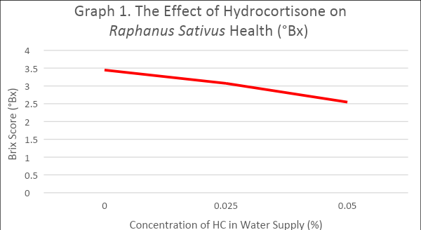

Table 2. The Descriptive and Inferential Statistical Analysis of The Effect of Hydrocortisone on *Raphanus Sativus* Health (°Bx)

|  |  |  |  |
| --- | --- | --- | --- |
| Descriptive Information | Pure HC in Water Supply | | |
| 0% HC Contamination | 0.025% HC Contamination | 0.05% HC Contamination |
| Mean  Range  Minimum Value  Maximum Value  Variance  Standard Deviation  1 SD  2 SD  3 SD  Number | 3.449 °Bx  0.861 °Bx  3.136 °Bx  3.997 °Bx  0.052  0.228  3.221-3.677  2.993-3.905  2.765-4.133  25 | 3.074 °Bx  0.773 °Bx  2.841 °Bx  3.614 °Bx  0.033  0.182  2.892-3.256  2.71-3.438  2.528-3.62  25 | 2.547 °Bx  0.872 °Bx  2.116 °Bx  2.988 °Bx  0.070  0.265  2.282-2.812  2.017-3.077  1.752-3.342  25 |
| Results of the t-test  0% HC vs. 0.025% HC t = 6.431 p < 0.01  0% HC vs. 0.05% HC t = 12.912 p < 0.01  0.025% HC vs. 0.05% HC t = 8.210 p < 0.01  At df = 48, α = 0.01, table-t = 2.407 for significance | | | |

Table 3. Concatenated Algorithms Estimate Brix, Specific Gravity, and Percent Fermentable Alcohol in Different HC Contaminated Environments

|  |  |  |  |
| --- | --- | --- | --- |
| Lake Terrain | Brix | Specific Gravity (Unitless) | Fermentable Alcohol (%) |
| Mono | 2.995°Bx | 1.012 | 1.50% |
| Crater | 3.379°Bx | 1.013 | 1.70% |
| Pyramid | 3.402°Bx | 1.013 | 1.70% |
| Seneca | 3.367°Bx | 1.013 | 1.70% |
| Cayuga | 3.311°Bx | 1.012 | 1.60% |

Figure 1. 3D Model of Hydrocortisone Generated by MolView Labs

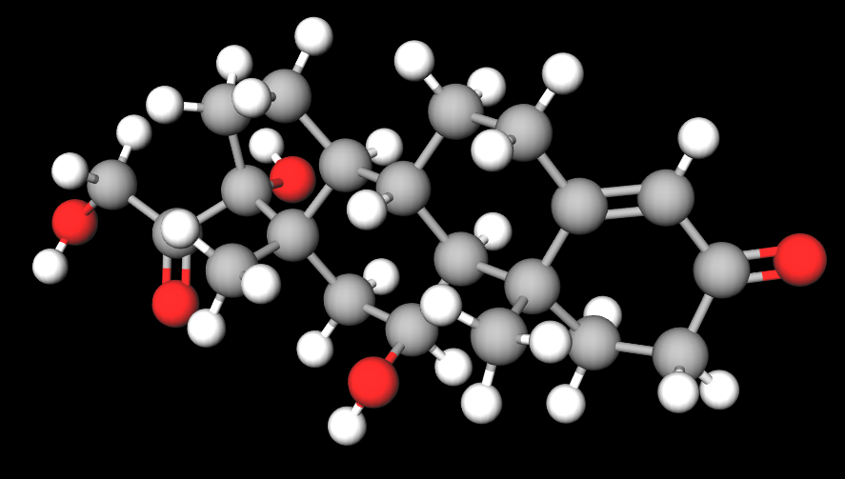

Figure 2. Assessments of Algorithm Performance: Initial and SRSM Data Frequency Distributions with Performance of Linear DNN Model

|  |
| --- |
|  |
|  |
|  |

Figure 3. Flowchart Depicting Data Reshaping and Modified Bootstrapping

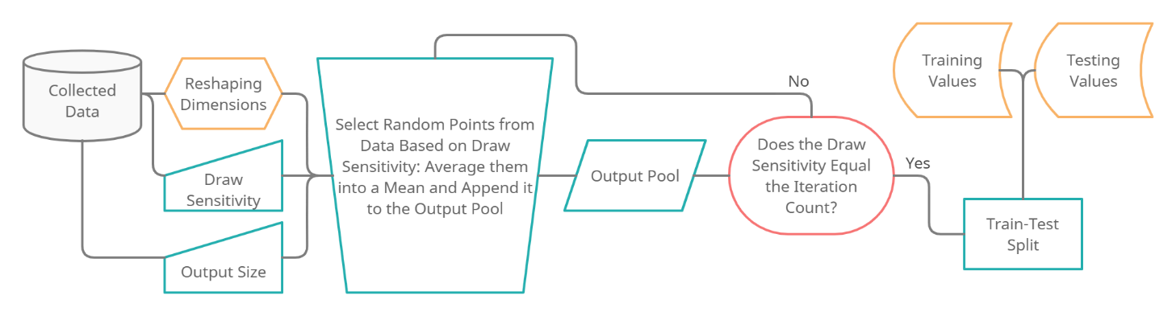

Figure 4. Flowchart Depicting DNN Optimization and Training

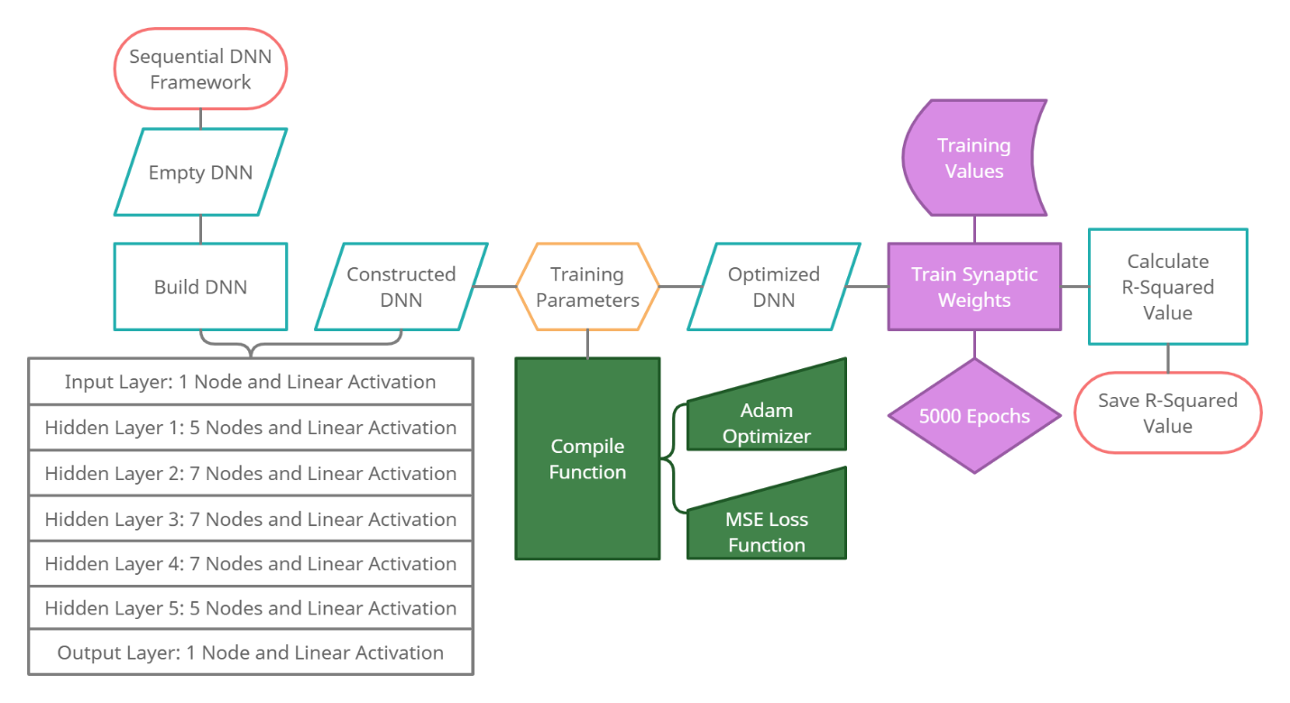

Figure 5. Flowchart Depicting Calculation and Conversions for Concentrations

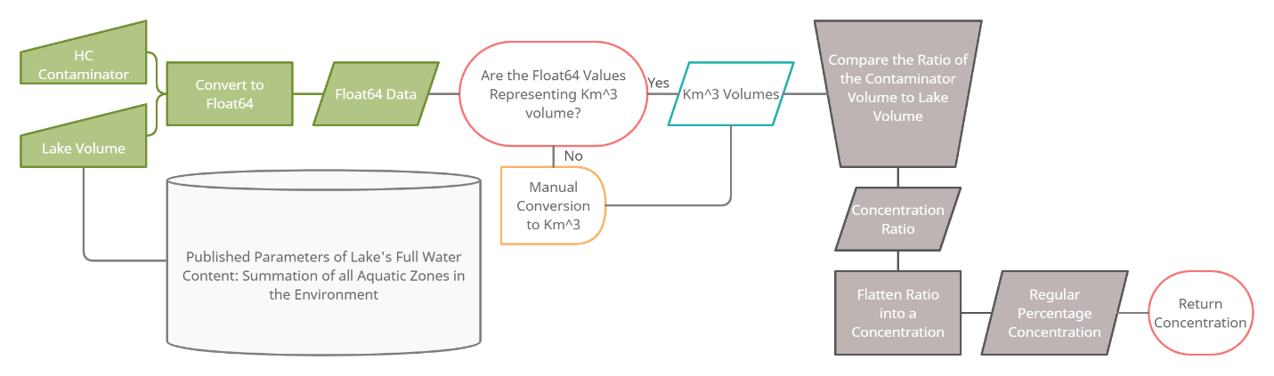

Figure 6. Mathematical Theory of Algorithms Used

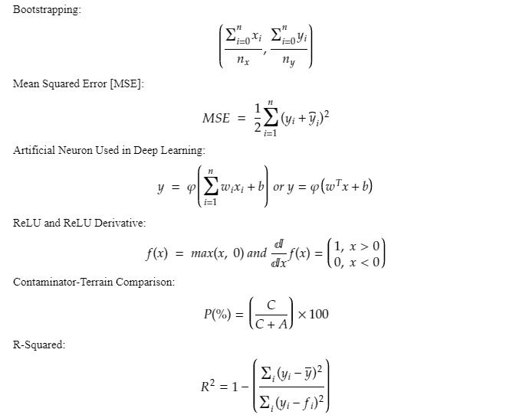

Figure 7. Mathematical Theory of Statistics Used

